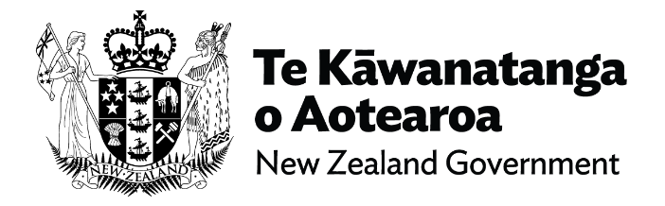
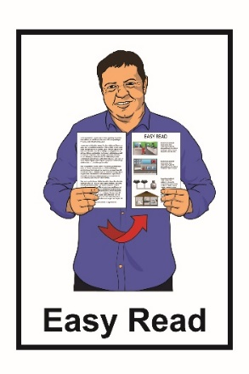

Te Rautaki Matihiko mō Aotearoa

The Digital Strategy for
Aotearoa New Zealand
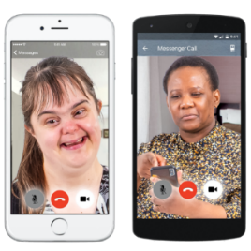
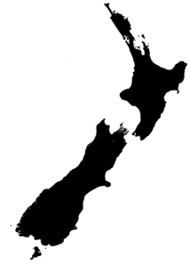

September 2022
What you will find in here

Page number:
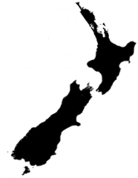

What is the Digital Strategy
for Aotearoa New Zealand? 3

Vision 5

Themes 8

Opportunities 9

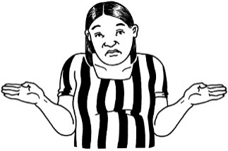
Challenges 12

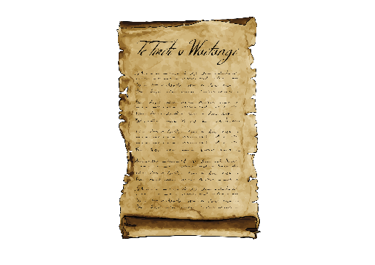
Te Tiriti o Waitangi –
The Treaty of Waitangi 14

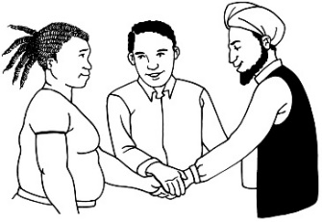
Page number:

Mahi Tika — Trust 17
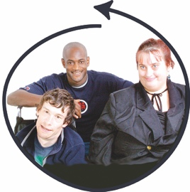

Mahi Tahi — Inclusion 20
GROWTH

Mahi Ake — Growth 23

Measuring success 26

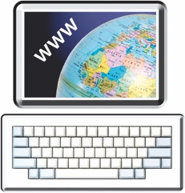
Where to find more
Information 31

What is the Digital Strategy
for Aotearoa New Zealand?

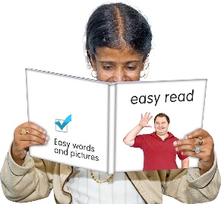
This document is an Easy Read summary of the Digital Strategy for Aotearoa New Zealand.

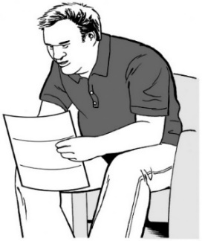
A summary:

- is shorter than the full Strategy
- tells you the main ideas.

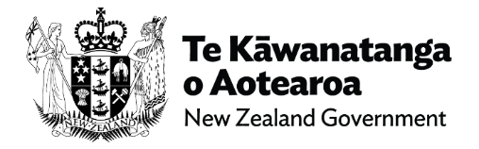
The Digital Strategy for Aotearoa New Zealand:
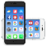
- has been written by the New Zealand Government

- is a plan of how digital technology can be used by everyone in Aotearoa New Zealand.
Digital technology includes things like:
- the internet

- smartphones or mobile phones
- computers or laptops

- iPads or Chromebooks

- video calling like Zoom or Skype
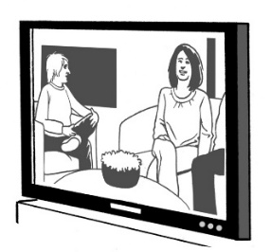
- smart televisions.

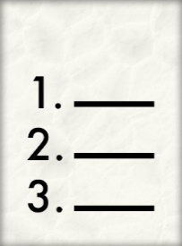
In this Easy Read document we will call the Digital Strategy for Aotearoa New Zealand the Strategy for short.
The Strategy

Vision

Vision means what the Government wants to see happen with digital technology.

The vision of the Strategy is for there to be better use of digital technology in Aotearoa New Zealand for:

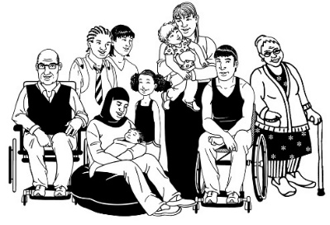
- people

- communities

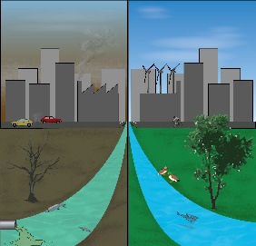
- the environment
🗸
- the economy.

Environment means places we live / Earth.

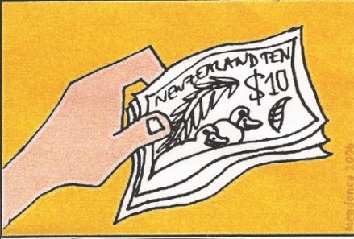
An economy is the way people in a country:

- spend money
- make money

- work / have jobs.
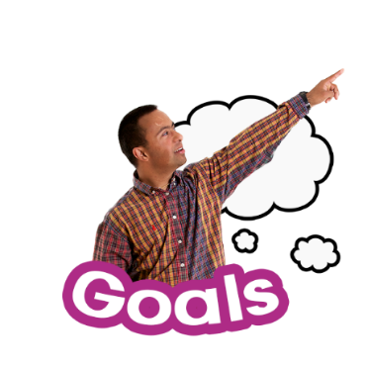

The Strategy sets goals for the use of digital technology in Aotearoa New Zealand.

The Strategy looks at:

- the steps the Strategy will take to reach the goals
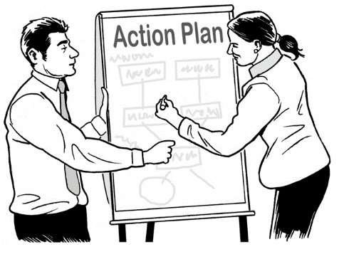
- the actions needed to make the goals a success.

The Strategy looks at:
The Strategy

- opportunities

- challenges.

Opportunities are chances or situations to make things better.

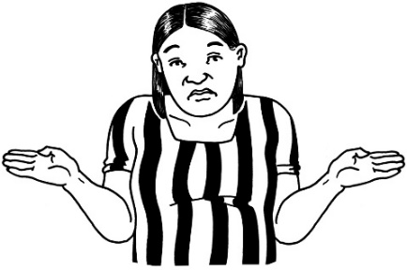
Challenges are things that can make it hard to do.

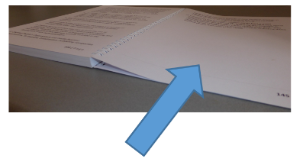
We will look more at what these opportunities and challenges might be on pages 9 to 13 of this document.

Themes

The Strategy
The Strategy is built around 3 key themes.

A theme is like a group of ideas.

Each theme has a set of goals to direct the work.

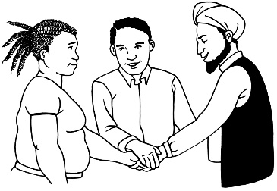
The 3 themes are:

- Mahi Tika — Trust
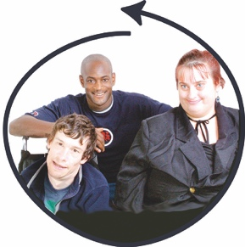

- Mahi Tahi — Inclusion

GROWTH
- Mahi Ake — Growth.

Opportunities

New types of digital technology and data driven technology are happening quickly.

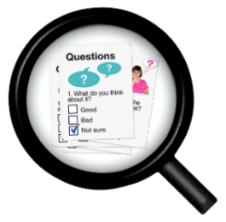
Data-driven technology is when organisations get feedback from people using digital technology.

As new digital technology is being made there could opportunities for people to:

- use this digital technology

- create new digital technology.

The Strategy also talks about opportunities such as:
The Strategy

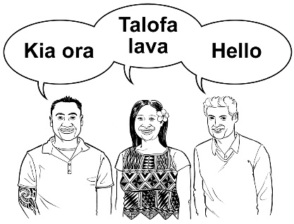
- showing the world:

- our country

- our people

- our values / things that are important to us
$
GROWTH
$
$
- making the economy:

- stronger

- able to keep growing
- using technology in a way that is better for the environment such as moving into a low-emissions economy.

A low-emissions economy is an economy that uses energy sources that cause less damage to the environment.
🗸

Challenges

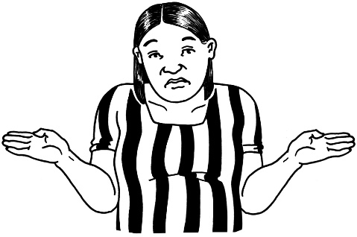
With digital technology being used more it also means there could be challenges along the way like:
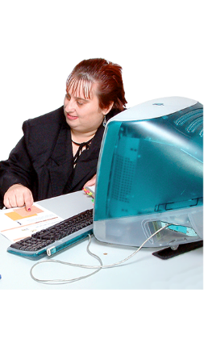
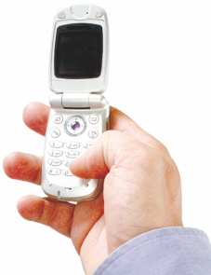
- people having digital technology that becomes outdated / can no longer be used

- some groups of people that:
- cannot get or use digital technology

- are left out of getting information because they do not have digital technology

- some groups of people being at bigger risk of online harm.

Online harm is when people get hurt by things that happen while using digital technology.

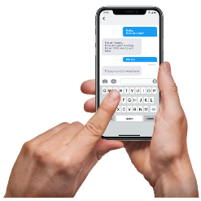
Some examples of online harm are:

- people saying mean things to a person on social media

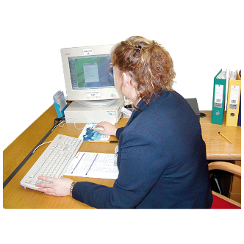
- people using the internet to pretend to be someone they are not

- people having money stolen from their bank accounts
- people saying or writing things online that are not true.

Te Tiriti o Waitangi / The Treaty of Waitangi

Te Tiriti o Waitangi / The Treaty of Waitangi is an important agreement between Māori and the British Crown.

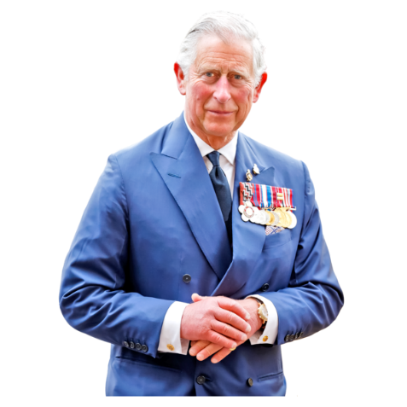
The British Crown means whoever is the British:

- King

- Queen.

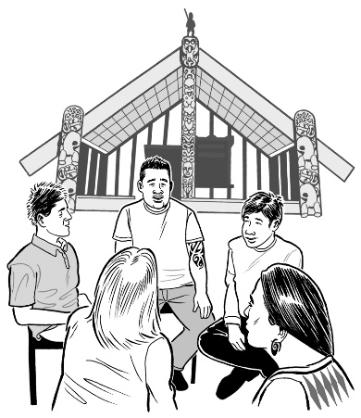
The Treaty is about Māori and the New Zealand Government:
- working together
- protecting things that are important to Māori.

The Government:
The Strategy

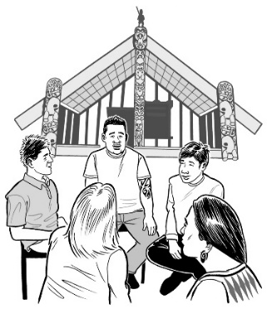
- must honour the ideas in the Treaty when working on this Strategy

- has talked with Māori about what they want to see in the Strategy.

There were 4 ideas that came out of these talks with Māori that are part of the Strategy.

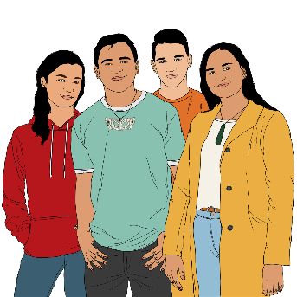
The first of these 4 ideas is that:

- Rangatahi / young people are the people who will work most with digital technology in the years to come.

The rest of these 4 ideas are that:

- Everyone needs to work together to put in place the vision / actions of the Strategy
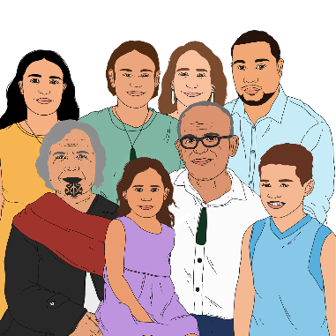
- Māori need to be a part of making digital technology for Māori that creates positive change

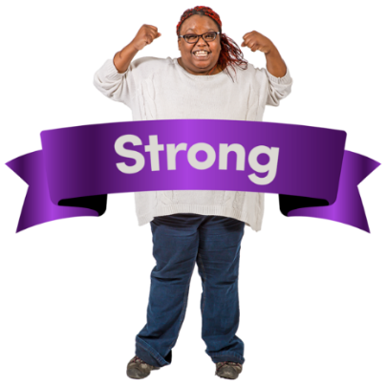
- Digital technology needs to support people’s:

- wellbeing

- cultural identity.

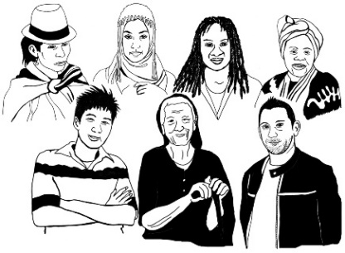
Cultural identity is when someone has a sense of belonging to a group of people that share things in common with them.

Mahi Tika — Trust

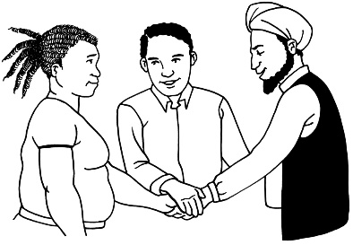
Mahi Tika / Trust is making sure:

- can rely on digital technology to do the right things
- are safe online
- are fair online
- respect each other.

One of the goals for this theme is:
- When using online digital technology New Zealanders feel they are:

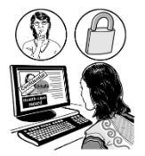
- safe

- confident / know how to use it

- in control of what they are doing.
Some more goals for this theme are:

- Organisations use digital technology in ways that:

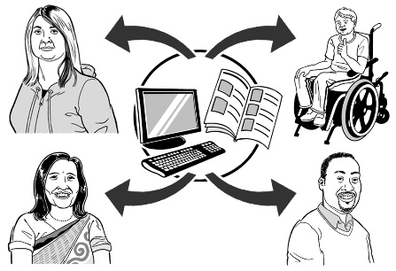
- are fair

- can be trusted

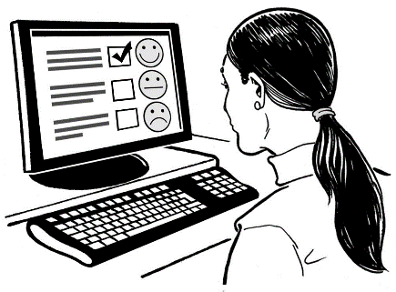
- show respect towards all cultures.

- Digital technology:

- works in the way it was meant to

- is safe / secure.

For each goal it is important to make sure trust is built / kept.
🗸

🗸

🗸

Goals

This will be done by:

- getting the right online safety in place

- working together with organisations to shape digital technologies in the years to come

- using plans that can change over time to create stronger:

- cyber security

- online safety.

Cyber security is about keeping people safe online when they use digital technology.

Mahi Tahi — Inclusion

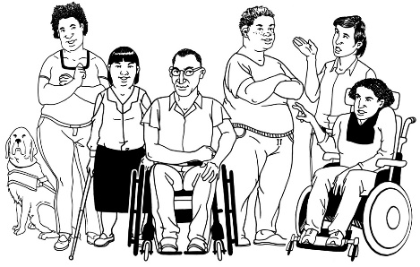
Mahi Tahi / Inclusion is about making sure everyone in Aotearoa New Zealand has access to digital technology.

There are 2 goals that go with this theme.

The first goal is:

- All New Zealanders can take part in using digital technology by:

- having the right digital technology for them

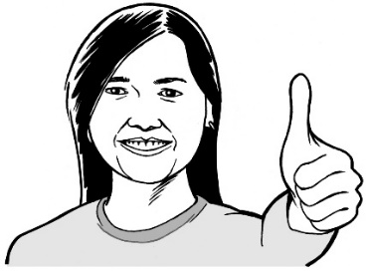
- knowing how to use digital technology

- having the confidence to use digital technology.
The second goal for this theme is:

- The needs of all New Zealanders are met through:

- content

- services.

Content means making sure that everyone can get the information they need in a way they can use.

Services means people everywhere in Aotearoa New Zealand being able to:
- connect to the internet
- use digital technology.

Some ways to make sure inclusion can happen sooner are to:

- make sure the needs of everyone are met when it comes to:

- content

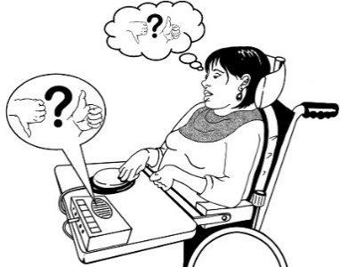
- services

- find ways of checking that everyone has their digital technology needs met.

Mahi Ake — Growth

GROWTH
Mahi Ake / Growth is about moving Aotearoa New Zealand into a better digital future.

Future means the years to come.

There are 2 goals that go with this theme.

The first goal is:

- Doing new things in better ways when we use digital technology in our:
- businesses

- organisations.

The second goal is:

- Having a digital technology sector that is:

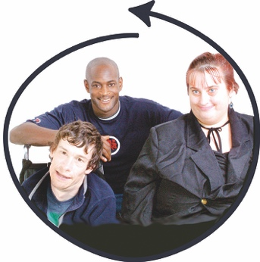
- working well

- growing at a fast rate

- inclusive.

This theme will work to:

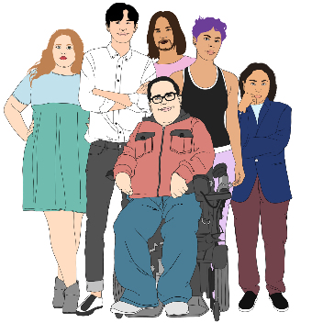
- build up the skills of people who work in using or making digital technology

- make sure there are lots of different people working in the digital technology sector
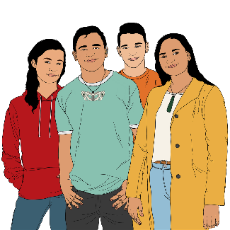
- support Māori with new ideas / ways of doing things in the digital technology sector.
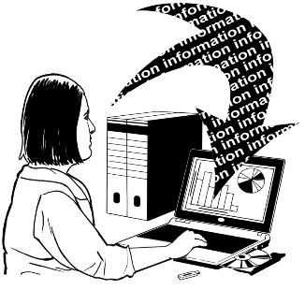
This theme will also work in a way that uses data / information to guide making new digital technology.

Measuring success

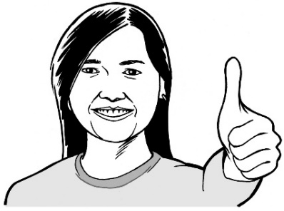
Measuring success means being able to see that things are getting better.

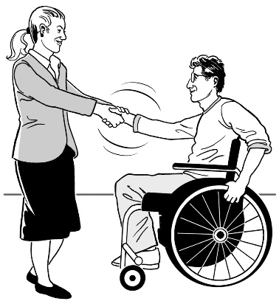
Work is already happening in each of the 3 theme areas:

- across the public sector

- with a range of partners / organisations.

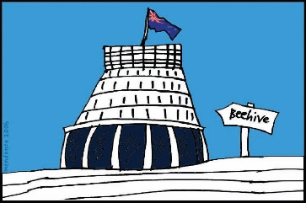
The public sector is the people who work in government departments.

The Action Plan that goes with the Strategy will be looked at every 12 months.
To know how well Aotearoa New Zealand is moving towards the goals in this Strategy there needs to be a clear idea of:
- what success looks like

- the steps to take to reach success.

Some measures of success are:

- all New Zealanders feel:
- safe online

- supported online

- our economy is able to deal well with cyber security threats / cyber attacks.

A cyber security threat is when someone wants to:

- steal private data or online information

- stop people or organisations from getting their own data or online information.

People who make cyber security threats are called cyber attackers.

Some more measures of success are that all New Zealanders:

- have what they need so they can use digital technology safely

- are able to use digital technology in a way that keeps their private information safe

- have good high speed / fast internet available

- can afford / have a:
- good internet connection
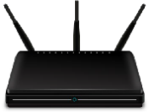
- digital device with access to the internet.

Some more measures of success are that:
GROWTH

- digital technology is on track to bring more money into our economy

- all New Zealand businesses are:

- set up with good digital systems from the beginning

- supported to take on the digital tools that work for them
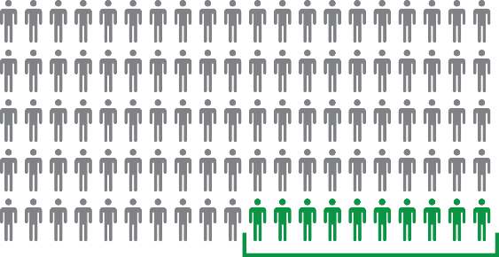
- at least 10 out of every 100 people work in the area of digital technology.

Where to find more information

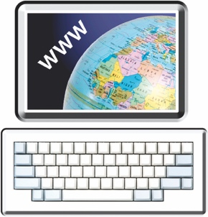
You can find the full Strategy and Action Plan on the New Zealand Government website:

www.digital.govt.nz/aotearoa

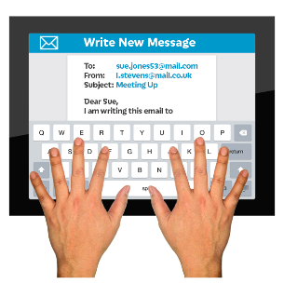
If you want more information you can:

Email: info@digital.govt.nz

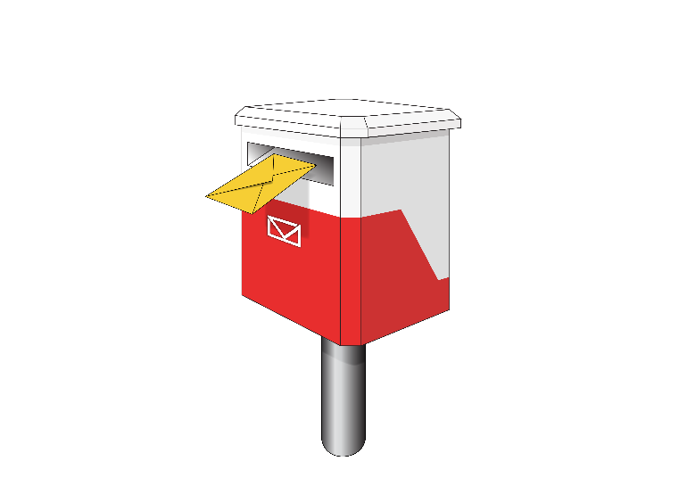
Write to: Digital Public Service
Department of Internal Affairs
PO Box 805
Wellington 6140
New Zealand.

This summary has been written by the Department of Internal Affairs.
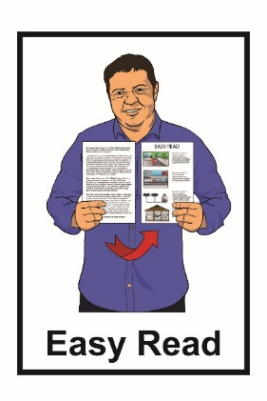
It has been translated into Easy Read with advice from the Make it Easy service of People First New Zealand Inc. Ngā Tāngata Tuatahi.

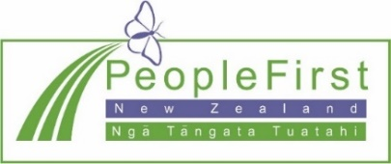
The ideas in this document are not the ideas of People First New Zealand Inc. Ngā Tāngata Tuatahi.
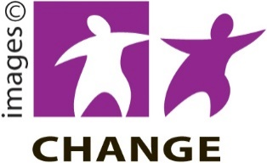
Make It Easy uses images from:

- Changepeople.org
- Photosymbols.com

- Sam Corliss
- Huriana Kopeke-Te Aho.

All images used in this Easy Read document are subject to copyright rules and cannot be used without permission.

